# Project Definition Document

For the BSc computer science Final year project   
at City, University of London   
Academic year 2021/2022

Project title:   
Visual Fabric Classification using Neural Networks

Student: Nathan Odibo | Email: nathan.odibo@city.ac.uk

Consultant: Dr. Martin Walter

Proposed by: Nathan Odibo

Arrangements for proprietary interests: None

Any other promises you are making in order to secure acceptance of the project: None

Word count: 1255 (Excluding Cover sheet, Index and Appendixes, Including references and section headers)

INDEX

Project Definition Document 1

Proposal 3

Problem to be solved 3

Project Objectives 4

Project Beneficiaries 4

Work Plan 4

Project Risks 5

Risks to your project 5

Risks that your project poses to others 6

References: 6

Appendix: Work Plan (Gant Chart) 7

Appendix: Research Ethics Review Form 8

## Proposal

### Problem to be solved

In today’s time, we have access to a multitude of different fabrics which all have their unique traits such as their fell to the touch, their ability to absorb or repel water, the friction it produces, and how much wear and tear it can withstand.

So, it is all the more important to choose the correct fabric or combination of different layers of fabrics to make clothes to fulfill a certain need.

Nonetheless, it is not quite easy to identify a fabric based on touch alone for a common individual, especially if they never used that fabric before, and the most proven method of identifying a fabric “the burn test” is not a reliable way for everyone to identify a fabric and not everyone might “read” the burning of the fabric correctly, besides that not all fabrics burn differently which makes it even harder to apply. (James V. 2021)

Among those problems, a common individual may not be too eager to learn about all the ways to identify all of the different kinds of fabrics and remember each distinguishing feature to identify if it is the fabric they are looking for, including the way it behaves when burning.  
On top of that, they may not even have the option of burning a piece of fabric since the flames are a risk to their surroundings, and the fabric they want to test might be too scarce and/or expensive to cut a piece out of.

The project aims to solve all these issues by providing a software solution to identify fabrics based on an image taken of the fabric based on the fabrics available in a dataset that will be used to train an AI model which will be trained using different classification models to choose the one with the best accuracy to display to an end user of the software solution what kind of fabric they have.

The data set used will be one provided on www.ibug.doc.ic.ac.uk/resources/fabrics / by C. Kampouri et al. (2016) that was made for a research paper by the same author group.

### Project Objectives

The project’s main objective is to create a classification model using neural networks for image classification, with an average accuracy of at least 70% as the dataset used does have a lack of certain images of some fabric types for the model to be trained on (e.g. There are no images for “fur” to train the model on at this point) and 70% is the average accuracy obtained within the report of C. Kampouri et al. (2016) which focuses on fabric classification.

Additional Objectives:

1. The application will be an executable that is not reliant on me for the provision of external resources such as hosting a server (the software operates offline once downloaded).
2. Different models and model options (e.g. adjusting layers and the amount thereof and changing the activation function) will be used to identify the model with the best accuracy for the classifications**.**
3. Artificially increase the dataset size by translating images (rotate, scale, add a colour layer), if there is only a small collection of certain images in the dataset for certain fabrics, and test the effects on the well-represented data.
4. The program will take an image and return the output from the classification with the confidence value and name of the detected fabric.

Optional Objectives:

* Improve the dataset by gathering additional images for fabrics that lack mane/any image sets (e.g. collect images for “fur”) and retrain the model to include them
* Make the software accessible through mobile devices or the web.
* Include more information about the fabric detected, such as additional checks that can be performed through touch or “the burn test”.
* Identify the conditions in which photos taken will yield the best results (distance, lighting, image specifications)

### Project Beneficiaries

On the success of the project, hobby sewers and commercial sewers alike should be able to benefit from it, should they be unsure about the type of a piece of fabric or don’t have enough experience with the fabric to identify it by themselves.  
  
The research could also benefit another researcher or larger companies who are interested in expanding the research in the classification of fabrics or automation of certain processes which would require a fabric classification model.

## Work Plan

This project will mainly python the panda library for data preparation and the TensorFlow, Keras library to perform the classification to and to create the predictions  
other libraries may be used if required, but these are the main ones, but tools such as anaconda which in addition to TensorFlow and Keras allow me to use Spyder and Jupiter-notebook to easily interpret the model’s outputs. (Gant chart in appendix)

## Project Risks

### Risks to your project

|  |  |  |  |  |
| --- | --- | --- | --- | --- |
| No. | Risk | Likelihood | Severity | Prevention/Mitigation |
| 1. | Low classification accuracy for underrepresented fabrics. | 7 | 4 | Identify the threshold of data required to perform accurate predictions, reduce the range of fabrics that will be classified.  Artificially increase data through different transformations.  Collect more data myself using my own camera. |
| 2. | 2 or more fabrics are commonly mistaken. | 4 | 4 | Artificially expand the dataset to allow the model to extract new features or to revalue the currently identified features.  Add a clause within the program to display the top *k* number of fabrics if they share a similar likelihood of being correct.  Analyze such occurrences beforehand to indicate if a fabric is similar to other fabrics when it has identified a fabric with this issue. |
| 3. | Unable to artificially expand the data may reduce the accuracy of the classifier.  By making the classifier disregard important features in the data. | 3 | 5 | Flipping of images should have no negative impact on the data for this problem, scaling and cropping should not have a negative impact to a degree, rotation, and translation are options for data augmentation, but they will create leftover space that will have to be accounted for in some way. Noise might be used to simulate worse camera quality. |
| 4. | The camera quality might not be high enough | 5 | 4 | My phone camera has a good quality for the purpose of data collection.  And alternatively, I should be able to either borrow a camera better suited for the task. |
| 5. | Lack of access to fabrics to photograph. | 1 | 3 | The same as the images in the dataset, I can take photographs of clothes of the looked-for fabric at clothing shops.  Alternatively, there are many more datasets or images of fabrics located on the web for free use. |
| 6. | Loss of my work by breaking/loss/theft of my computer. | 1 | 10 | Create a git repository on which my work will be maintained. |
| 7. | Unexpected delays | 7 | 7 | Schedule enough time within my workplan, to allow delays without threatening to be late for the final submission deadline. |

### Risks that your project poses to others

To avoid users of the software making a misinformed choice, any users will always be shown the confidence of accuracy of the prediction to indicate that the software is not flawless and to avoid that a user makes a choice based solely on the outcome of any first prediction the software makes.

# References:

James V., 2021. How To Tell If Fabric Is… (How to Identify Fabrics Easily). [online] Sewingiscool. Available at: <https://sewingiscool.com/how-to-identify-fabrics/>(Accessed: 14.02.2022)

C. Kampouris, S. Zafeiriou, A. Ghosh, S. Malassiotis. (2016) The Fabrics Dataset. [online] ibug.doc. Available at: <https://ibug.doc.ic.ac.uk/resources/fabrics/>(Accessed: 14.02.2022)

C. Kampouris, S. Zafeiriou, A. Ghosh, S. Malassiotis. (2016) Fine-grained material classification using micro-geometry and reflectance, 14th European Conference on Computer Vision, Amsterdam.

## Appendix: Work Plan (Gant Chart)

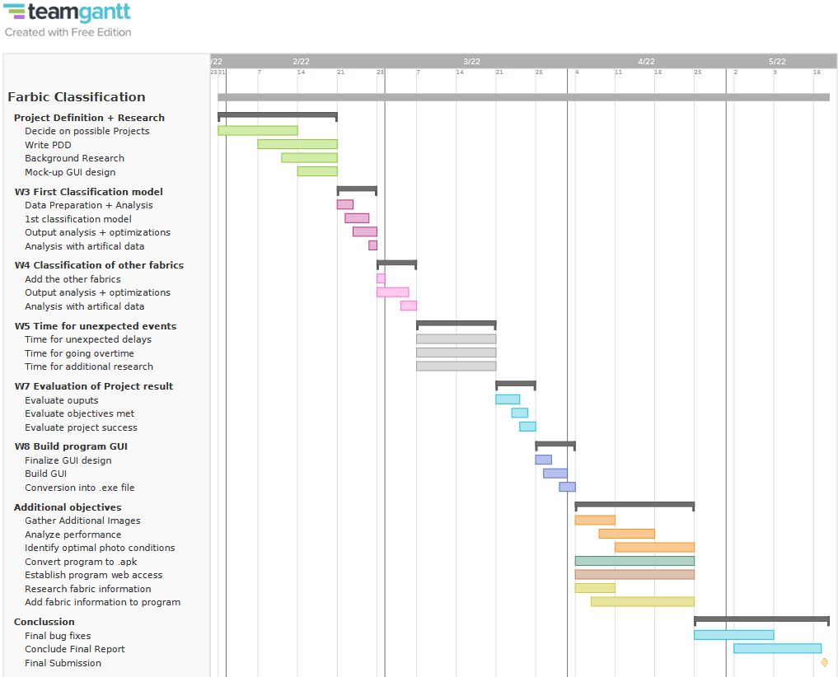

## Appendix: Research Ethics Review Form

|  |
| --- |
| **Research Ethics Review Form: BSc, MSc and MA Projects**  **Computer Science Research Ethics Committee (CSREC)**  <http://www.city.ac.uk/department-computer-science/research-ethics> |

Undergraduate and postgraduate students undertaking their final project in the Department of Computer Science are required to consider the ethics of their project work and to ensure that it complies with research ethics guidelines. In some cases, a project will need approval from an ethics committee before it can proceed. Usually, but not always, this will be because the student is involving other people (“participants”) in the project.

In order to ensure that appropriate consideration is given to ethical issues, all students must complete this form and attach it to their project proposal document. There are two parts:

***PART A: Ethics Checklist***. All students must complete this part. The checklist identifies whether the project requires ethical approval and, if so, where to apply for approval.

***PART B: Ethics Proportionate Review Form****.* Students who have answered “no” to all questions in A1, A2 and A3 and “yes” to question 4 in A4 in the ethics checklist must complete this part. The project supervisor has delegated authority to provide approval in such cases that are considered to involve MINIMAL risk. The approval may be ***provisional*** *– identifying the planned research as*likely to involve MINIMAL RISK. In such cases you must additionally seek ***full approval*** from the supervisor as the project progresses and details are established. ***Full approval*** must be acquired in writing, before beginning the planned research.

**Part A: Ethics Checklist**

|  |  |  |
| --- | --- | --- |
| **A.1 If you answer YES to any of the questions in this block, you must apply to an appropriate external ethics committee for approval and log this approval as an External Application through Research Ethics Online - https://ethics.city.ac.uk/** | | *Delete as appropriate* |
| 1.1 | Does your research require approval from the National Research Ethics Service (NRES)? | **NO** |
| 1.2 | Will you recruit participants who fall under the auspices of the Mental Capacity Act? | **NO** |
| 1.3 | Will you recruit any participants who are currently under the auspices of the Criminal Justice System, for example, but not limited to, people on remand, prisoners and those on probation? | **NO** |
| **A.2 If you answer YES to any of the questions in this block, then unless you are applying to an external ethics committee, you must apply for approval from the Senate Research Ethics Committee (SREC) through Research Ethics Online -**  **https://ethics.city.ac.uk/** | | *Delete as appropriate* |
| 2.1 | Does your research involve participants who are unable to give informed consent? | **NO** |
| 2.2 | Is there a risk that your research might lead to disclosures from participants concerning their involvement in illegal activities? | **NO** |
| 2.3 | Is there a risk that obscene and or illegal material may need to be accessed for your research study (including online content and other material)? | **NO** |
| 2.4 | Does your project involve participants disclosing information about special category or sensitive subjects? | **NO** |
| 2.5 | Does your research involve you travelling to another country outside of the UK, where the Foreign & Commonwealth Office has issued a travel warning that affects the area in which you will study? | **NO** |
| 2.6 | Does your research involve invasive or intrusive procedures? | **NO** |
| 2.7 | Does your research involve animals? | **NO** |
| 2.8 | Does your research involve the administration of drugs, placebos or other substances to study participants? | **NO** |
| **A.3 If you answer YES to any of the questions in this block, then unless you are applying to an external ethics committee or the SREC, you must apply for approval from the Computer Science Research Ethics Committee (CSREC) through Research Ethics Online - https://ethics.city.ac.uk/**  **Depending on the level of risk associated with your application, it may be referred to the Senate Research Ethics Committee.** | | *Delete as appropriate* |
| 3.1 | Does your research involve participants who are under the age of 18? | **NO** |
| 3.2 | Does your research involve adults who are vulnerable because of their social, psychological or medical circumstances (vulnerable adults)? | **NO** |
| 3.3 | Are participants recruited because they are staff or students of City, University of London? | **NO** |
| 3.4 | Does your research involve intentional deception of participants? | **NO** |
| 3.5 | Does your research involve participants taking part without their informed consent? | **NO** |
| 3.5 | Is the risk posed to participants greater than that in normal working life? | **NO** |
| 3.7 | Is the risk posed to you, the researcher(s), greater than that in normal working life? | **NO** |
| **A.4 If you answer YES to the following question and your answers to all other questions in sections A1, A2 and A3 are NO, then your project is deemed to be of MINIMAL RISK.**  **If this is the case, then you can apply for approval through your supervisor under PROPORTIONATE REVIEW. You do so by completing PART B of this form.**  **If you have answered NO to all questions on this form, then your project does not require ethical approval. You should submit and retain this form as evidence of this.** | | *Delete as appropriate* |
| 4 | Does your project involve human participants or their identifiable personal data? | **NO** |

*\*\*If these items are not available at the time of submitting your project proposal, then* ***provisional approval*** *can still be given, under the condition that you must submit the final versions of all items to your supervisor for approval at a later date.* ***All*** *such items* ***must*** *be seen and approved by your supervisor before the activity for which they are needed begins. Written evidence of* ***final approval*** *of your planned activity must be acquired from your supervisor before you commence.*

**Changes**

If your plans change and any aspects of your research that are documented in the approval process change as a consequence, then any approval acquired is invalid. If issues addressed in Part A (the checklist) are affected, then you must complete the approval process again and establish the kind of approval that is required. If issues addressed in Part B are affected, then you must forward updated documentation to your supervisor and have received written confirmation of approval of the revised activity before proceeding.

**Templates for Consent and Information**

You must use the templates provided by the University as the basis for your participant information sheets and consent forms. You **must** adapt them according to the needs of your project before you submit them for consideration.

Participant Information Sheets, Consent Forms and Protocols must be consistent. Please ensure that this is the case prior to seeking approval. Failure to do so will slow down the approval process.

We strongly recommend using Qualtrics to produce digital information sheets and consent forms.

**Further Information**

<http://www.city.ac.uk/department-computer-science/research-ethics>

https://www.city.ac.uk/research/ethics/how-to-apply/participant-recruitment

https://www.city.ac.uk/research/ethics